 **ANNA UNIVERSITY** 

**NAAN MUDHALVAN – GUIDED PROJECT**

**SOLUTION ARCHITECTURE**

**FARMER INSURANCE CHAIN**

|  |  |
| --- | --- |
| DATE | 31 OCTOBER 2023 |
| TEAM MEMBERS WITH NM ID | 1. ASWIN KRISHNA M –   93A42A8D371667AB4A04EAAC81B6B402   1. BHARATHI R - EA3E07A3A89131DA782474D19C6F8249 2. BOOPATHI J- FEBCCCA7D2B925CB9D24C6BDAF4CB1AE 3. DEEPAK K - 8F31A2F3B69C15BB1AA4A19BACAD94F6 4. VINOTH P- 3B7F07DDBB06A4ABF8B47C6AAB51207F |
| PROJECT NAME | FARMER INSURANCE CHAIN |
| COLLEGE NAME | ALAGAPPA COLLEGE OF TECHNOLOGY, ANNA UNIVERSITY |

**Solution Architecture:**

Implement a centralized database or data warehouse that serves as the primary repository for all educational data, including student records, assessment results, attendance, and institutional performance data. This centralization ensures data consistency and accessibility. Employ robust user authentication and authorization mechanisms to control access to the system. Implement role-based access control, allowing administrators, educators, students, and parents to access specific data and functionalities based on their roles. Develop data integration processes and ETL workflows to consolidate data from various sources. These processes should include data mapping, transformation, and validation to ensure data accuracy before it is stored in the central repository. Build a data analytics and reporting engine that allows users to create, customize, and schedule reports and visualizations. Implement data analytics tools to derive meaningful insights from the educational data, aiding data-driven decision-making.

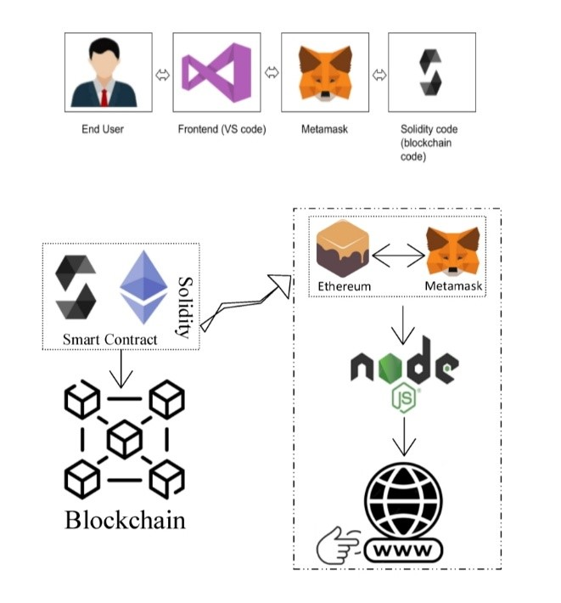

Schematic Diagram of Solution Architecture

Prerequisite:

1. download node.js : Node.js
2. download vs code: Li4nk
3. download metamask : https://metamask.io/

Steps to complete the project

Step 1:-

1. Open the Zip file and download the zip file.

2. Extract all zip files

Step 2 :

1.Open vs code in the left top select open folder. Select extracted file and open .

2. Select the projectname.sol file and copy the code.

3. Open the remix ide platform and create a new file by giving the name of projectname.sol and paste the code which you copied from vs code.

4. Click on solidity compiler and click compile the projectname.sol

5. Deploy the smart contract by clicking on the deploy and run transaction.

6. select injected provider - MetaMask. In environment

7. Click on deploy. Automatically MetaMask will open and give confirmation. You will get a pop up click on ok.

8. In the Deployed contract you can see one address copy the address.

9. Open vs code and search for the connector.js. In contract.js you can paste the address at the bottom of the code. In export const address.

10. Save the code.

Step 3: open file explorer

1. Open the extracted file and click on the folder.

2. Open src, and search for utiles.

3 . You can see the frontend files. Select all the things at the top in the search bar by clicking alt+ A. Search for cmd

4. Open cmd enter commands

npm install

npm bootstrap

npm start

5. It will install all the packages and after completing it will open {LOCALHOST IP ADDRESS} copy the address and open it to chrome so you can see the frontend of your project.